SQL Task

____________________________________

Basic queries:

Select all students => (SELECT * FROM Students ;)

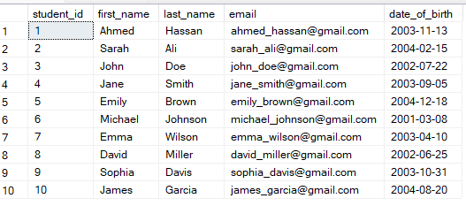

Select all courses=> (SELECT * FROM Courses ;)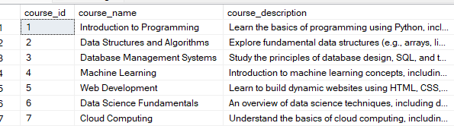

Select all enrollments with student names and course names => (

SELECT e.* , (s.first_name+' '+s.last_name)as full_name ,c.course_name from Enrollment as e

join Students as s

on e.student_id = s.student_id

join Courses as c

on e.course_id = c.course_id

)

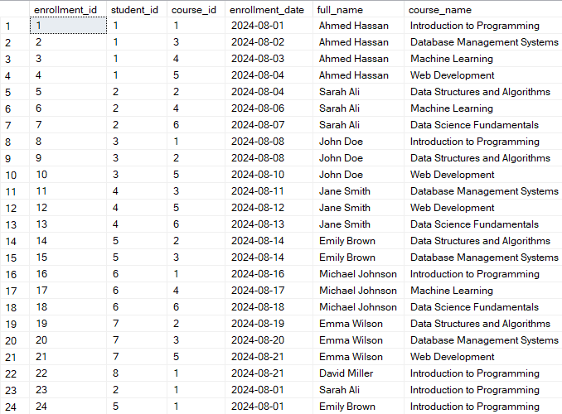

Advanced queries:

Select students who enrolled in a specific course => (SELECT c.course_name , (s.first_name+' '+s.last_name)as full_name from Enrollment as e

join Students as s

on e.student_id = s.student_id

join Courses as c

on e.course_id = c.course_id

where c.course_id = 1;)

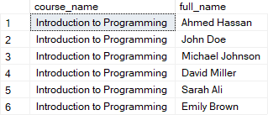

Select courses with more than 5 students => (SELECT c.course_name , count(e.course_id) as number_of_students from Enrollment as e

join Courses as c

on c.course_id = e.course_id

group by course_name

having count(e.course_id) > 5;)



Update a student's email = > (update Students

set email = 'ahmedhassanah027724@gmail.com'

where student_id = 1;)

Delete a course that no students are enrolled in => (delete from Courses

where course_id not in (

select distinct course_id

from Enrollment

);)

Calculate the average age of students => ( SELECT AVG(DATEDIFF(year , date_of_birth , GETDATE())) as average_age from Students ;)



Find the course with the maximum enrollments => (SELECT top 1 c.course_name ,count(e.course_id) as number_of_students from Enrollment as e

join Courses as c

on e.course_id = c.course_id

group by course_name

order by count(e.course_id) desc

)



List courses along with the number of students enrolled (use GROUP BY) =>(SELECT c.course_name ,count(e.course_id) as number_of_students from Enrollment as e

join Courses as c

on e.course_id = c.course_id

group by course_name)

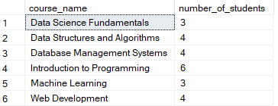

Join queries :

Select all students with their enrolled courses (use JOIN) => (SELECT s.* , c.course_name from Enrollment AS e

join Students AS s

ON e.student_id = s.student_id

join Courses AS c

ON e.course_id = c.course_id)

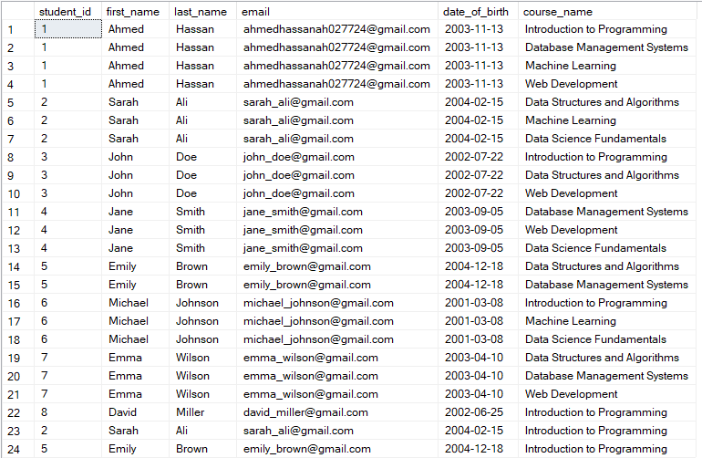

List all instructors and their courses => (SELECT i.* , c.course_name FROM Ins_to_course AS itc

join Instructors as i

on itc.instructor_id = i.instructor_id

join Courses as c

on itc.course_id = c.course_id)

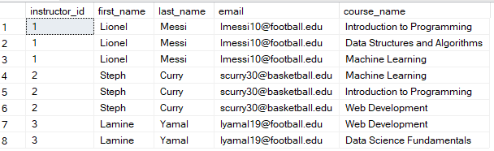

Find students who are not enrolled in any course => (

SELECT (first_name+' '+last_name) as 'full name' FROM Students

WHERE student_id NOT IN (SELECT DISTINCT student_id FROM Enrollment))



Supqueries and Set Operations

Select students enrolled in more than one course => (SELECT (s.first_name+' '+s.last_name) as 'full name' , count(e.student_id) AS 'course count' FROM Enrollment AS e

join Students as s

on e.student_id = s.student_id

group by s.first_name , s.last_name

having COUNT(e.student_id) >1)

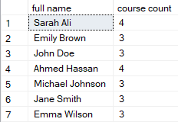

Find courses taught by a specific instructor => (select c.course_name , i.first_name + ' ' + i.last_name as 'instructor name' from Ins_to_course as itc

join Instructors as i

on itc.instructor_id = i.instructor_id

join Courses as c

on itc.course_id = c.course_id

where itc.course_id not in (select course_id from Ins_to_course

group by course_id

having count(course_id)>1))



Select the top 3 students with the most enrollments =>(select top 3 (s.first_name +' '+s.last_name) as 'student name' , count(e.student_id) as 'number of courses' from Enrollment as e

join Students as s

on e.student_id = s.student_id

group by s.first_name , s.last_name

order by count(e.student_id) desc

)

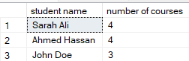

Use UNION to combine results of two different SELECT queries =>(

SELECT

(first_name +' '+last_name) as 'full name'

FROM

Students

UNION

SELECT

(first_name +' '+last_name) as 'full name'

FROM

Instructors;)

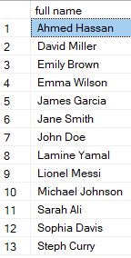

Functions and Stored Procedures:

Create a stored procedure to add a new student =>(CREATE PROCEDURE AddNewStudent

@FirstName NVARCHAR(100),

@LastName NVARCHAR(100),

@Email NVARCHAR(100),

@BirthDate DATE

AS

BEGIN

INSERT INTO Students (first_name, last_name, email, date_of_birth)

VALUES (@FirstName, @LastName, @Email, @BirthDate);

END;

EXEC AddNewStudent 'omar' ,'nouh' , 'omar_nouh@gmail.com' , '2004-3-1')

Create a function to calculate the age of a student based on their date of birth => (CREATE FUNCTION CalculateAge (@BirthDate DATE)

RETURNS INT

AS

BEGIN

RETURN DATEDIFF(YEAR, @BirthDate, GETDATE())

END;

SELECT

first_name,

last_name,

dbo.CalculateAge(date_of_birth) AS Age

FROM

Students;)

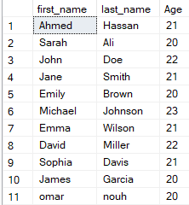

Aggregate Function and Grouping:

Calculate the total number of students =>(SELECT

COUNT(*) AS TotalNumberOfStudents

FROM

Students;)



Calculate the average, minimum, and maximum number of enrollments per course => (SELECT

AVG(enrollment_count) AS AverageEnrollments,

MIN(enrollment_count) AS MinimumEnrollments,

MAX(enrollment_count) AS MaximumEnrollments

FROM (

SELECT

course_id,

COUNT(student_id) AS enrollment_count

FROM

Enrollment

GROUP BY

course_id

) AS EnrollmentStats;)

